Shift Registers

To design (a) SISO (b) SIPO (c) PIPO (d) PISO using Verilog

(i) SISO

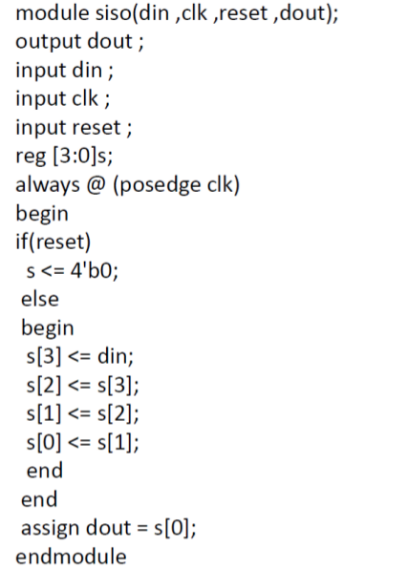

Testbench
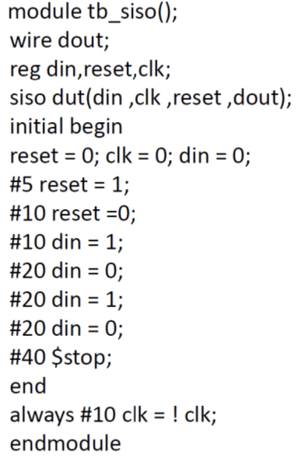

Simulation Waveform

Report Utilization Summary

(ii)SIPO

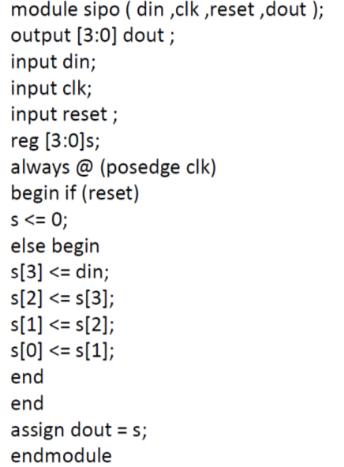

Testbench
module tb_sipo;
reg din,clk,reset;
wire [3:0] dout;
sipo uut(din, clk, reset,dout);

initial
begin
reset=0;
clk=0;
din=0;
#20 reset =1;
#20 reset=0;
#20 din=1;
#20 din=0;
#20 din=1;
#20 din=0;
#20 din=1;
#20 $finish;
end
always #10 clk = ~ clk;
endmodule

Simulation Waveform

Report Utilization Summary

(iii)PIPO
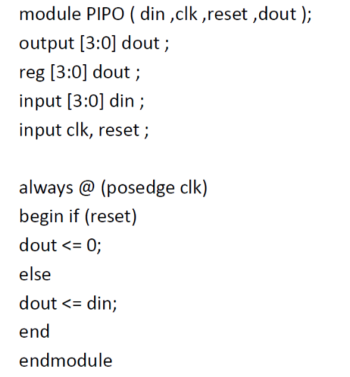

Testbench
module tb_pipo;
reg [3:0] din;

reg clk,reset;
wire [3:0] dout;
pipo uut(din, clk, reset,dout);

initial
begin
reset=0;
clk=0;
din=4'b0000;
#20 reset =1;
#20 reset=0;
#60 din=4'b1001;
#60 din=4'b1010;
#60 din=4'b1111;

#60 $finish;
end
always #10 clk = ~ clk;
endmodule
Simulation Waveform

Report Utilization Summary

(iv) PISO
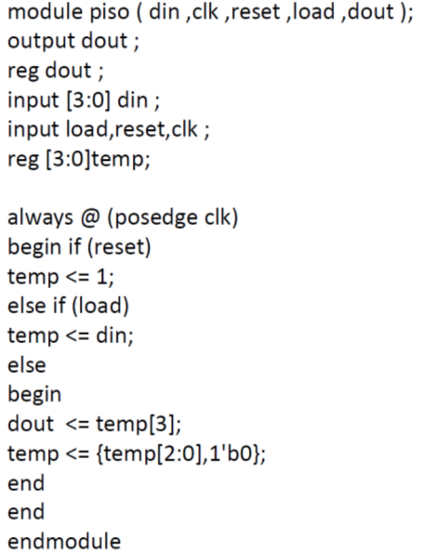

Testbench
module tb_piso;
reg [3:0] din;

reg clk,reset,load;
wire dout;
piso uut(din, clk, reset,loaddout);

initial
begin
reset=0;
load=0;
clk=0;
din=4'b0000;
#20 reset =1;
#20 reset=0;
#20 load =1;
#20 load =0;

#60 din=4'b1001;
#60 din=4'b1010;
#60 din=4'b1111;

#60 $finish;
end
always #10 clk = ~ clk;
endmodule

Simulation Waveform

Report Utilization Summary

